

CMSC 150 - Numerical and Symbolic Computation University of the Philippines Los Baños
A.Y. 2025-2026

GREEN OPTIMIZATION SYSTEM
USER MANUAL

Developer: Ivan Joas B. Managat Instructor: Prof. Ariel B. Doria

Table of Contents

Introduction 3
System Requirements 3
Installation and Setup 4
Getting Started 5
User Interface Overview 5
How to Use the Application 6
Understanding the Results 8
Contact and Support 10

1. INTRODUCTION

Welcome to the Green Optimization System User Manual!

1.1 What is this application?
The Greenvale Pollution Reduction Optimization System is an interactive web application designed to help the fictional City of Greenvale determine the most cost-effective combination of environmental mitigation projects to meet pollution reduction targets.
1.2 Purpose
This application demonstrates the practical application of Linear Programming and the Simplex Method to solve real-world environmental optimization problems.
1.3 Problem Statement
The City of Greenvale must reduce 10 types of pollutants to meet national environmental standards:
- CO₂, NOₓ, SO₂, PM2.5, CH₄, VOC, CO, NH₃, Black Carbon (BC), N₂O
The city has access to 30 different mitigation projects, each with:
- Specific implementation costs
- Varying pollutant reduction capabilities
- Implementation limits (0-20 units per project)
Goal: Find the minimum-cost combination of projects that meets or exceeds all pollution reduction targets.

2. SYSTEM REQUIREMENTS

2.1 Software Requirements
- R (version 4.0.0 or higher)
- RStudio (recommended for easier setup)
- Web Browser (Chrome, Firefox, Edge, or Safari)
2.2 Required R Packages
install.packages("shiny")
install.packages("DT")
install.packages("shinyjs")
2.3 Hardware Requirements
- Processor: Any modern CPU (2 GHz or higher recommended)
- RAM: 4 GB minimum (8 GB recommended)
- Storage: 50 MB free space
- Display: 1280x720 minimum resolution (1920x1080 recommended)

3. INSTALLATION AND SETUP

3.1 Download the Application
- Extract the application files to a folder (e.g., Greenvale_Optimizer/)
- Verify the folder structure:
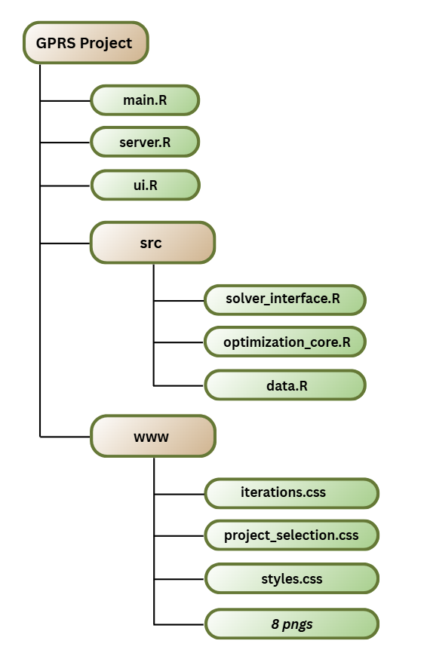
3.2 Install Required Packages
Open R or RStudio and run:
install.packages(c("shiny", "DT", "shinyjs"))
3.3 Launch the Application
- Open RStudio
- Set your working directory to the application folder:
- setwd("path/to/Greenvale_Optimizer")
- Run the application:
- source("main.R")
- The application will automatically open in your default web browser

4. GETTING STARTED

4.1 Welcome Screen
When you first launch the application, you'll see an animated welcome screen featuring:
- Greenvale city skyline with plants (representing environmental restoration)
- Navigation buttons:
  - Main - Go to the project selection page
  - Credits - View developer and course information
  - About this App - Learn about the application's purpose and methodology
- Get Started button - Begin using the optimizer
4.2 First-Time User Tips
- Click "About this App" to understand the problem
- Review the Instructions (info icon) on the Project Selection page
- Start with "Select All" to see a feasible solution
- Experiment with different project combinations

5. User Interface Overview

The application has 3 main sections:
5.1 Welcome Tab
- Introduction and navigation
- Access to credits and application information
5.2 Project Selection Tab
The main workspace, divided into 6 panels:
Upper-Left Panel: Instructions & Controls
- Step-by-step instructions
- Select All button - selects all 30 projects
- Reset button - clears all selections and results
- Run Optimization button - solves the problem
Bottom-Left Panel: Target Pollutants
- Displays the required reduction for each of the 10 pollutants
- Values shown in tons
Center Panel: Project Grid
- 30 project cards showing:
  - Project name
  - Cost per unit
  - Info button (i) - view detailed pollutant reductions
- Click a card to select/deselect it
- Selected cards have a green-yellow glow
Upper-Right Panel: Optimization Summary
- Shows results after optimization:
  - Status badge (Feasible/Infeasible)
  - Optimal Cost (if feasible)
  - Projects Used count
  - Iterations icon - jump to Simplex Iterations tab
Bottom-Right Panel
- Reserved for future features
5.3 Simplex Iterations Tab
- Return Home button (upper-left)
- Iteration Viewer (right side):
  - Dropdown to select specific iterations
  - Navigation buttons (Previous, Next, Jump to Optimal)
  - Basic Solution table - shows variable values
  - Tableau table - shows the full simplex tableau

6. How to Use the Application

Step 1: Select Projects
- Navigate to the Project Selection tab
- Click on project cards to select them
  - Selected cards will glow green-yellow
  - Click again to deselect
- Quick selection options:
  - Click "Select All" to choose all 30 projects
  - Click "Reset" to clear all selections
Step 2: View Project Details (Optional)
- Click the "i" icon on any project card
- A modal will appear showing:
  - Project name
  - Estimated cost per unit
  - Pollutant reduction breakdown (tons per unit)
- Close by clicking the X or clicking outside the modal
Step 3: Run the Optimization
- Click the "Run Optimization" button
- The system will:
  - Build constraint matrices
  - Apply the Simplex Method
  - Find the optimal solution (if feasible)
- Processing typically takes 1-3 seconds
Step 4: Review Results
After optimization completes, a Results Modal appears showing:
For Feasible Solutions:
- FEASIBLE status badge
- Optimized Cost - minimum cost to meet all targets
- Your Input - all projects you selected
  - ✓ Checkmark = project used in solution
  - ○ Circle = project not needed
- Solution & Cost Breakdown:
  - Ranked list of projects actually used
  - Units allocated to each project
  - Unit cost and total cost per project
  - Visual contribution bar
For Infeasible Solutions:
- INFEASIBLE status badge
- Explanation message
- Suggestions:
  - Select more projects
  - Include projects with diverse pollutant coverage
  - Consider high-impact options
6.2 Advanced Features
Viewing Simplex Iterations
- From the Results Modal, click "View Simplex Iterations"
  - OR click the iterations icon (⟳) in the Optimization Summary panel
- Use the dropdown to navigate between iterations:
  - Iteration 0 - Initial Tableau
  - Iteration 1, 2, 3... - Each pivot operation
  - Final Iteration - Optimal solution
- Each iteration displays:
  - Basic Solution - current variable values
  - Tableau - full constraint matrix with objective function
  - Pivot information - which row and column were pivoted
Comparing Different Scenarios
- Try different project combinations:
  - Select only renewable energy projects
  - Select only transportation projects
  - Mix different project types
- Click "Reset" between scenarios
- Compare optimal costs to find the best strategy

7. UNDERSTANDING THE RESULTS

7.1 Interpreting the Optimal Cost
- The Optimal Cost represents the minimum total expenditure needed to meet all pollution targets
- This is the sum of: (Units × Cost per Unit) for each project used
- Example: If Optimal Cost = $425,000, this is the cheapest way to achieve all targets with your selected projects
7.2 Understanding Project Units
- Each project shows Units - how many times it should be implemented
- Units can be fractional (e.g., 12.5 units)
- This represents partial implementation or phased rollout
- Range: 0 to 20 units per project (constraint)
7.3 Project Selection Logic
Why some selected projects aren't used:
- You might select 15 projects, but only 8 are actually needed
- The optimizer chooses the most cost-effective combination
- Some projects may be:
  - Too expensive for the pollution reduction they provide
  - Redundant (other projects cover the same pollutants more cheaply)
  - Not needed to meet minimum targets
7.4 Pollutant Targets
Each pollutant has a minimum reduction target (in tons):

- CO₂: 1,000 tons
- NOₓ: 35 tons
- SO₂: 25 tons
- PM2.5: 20 tons
- CH₄: 60 tons
- VOC: 45 tons
- CO: 80 tons
- NH₃: 12 tons
- BC: 6 tons
- N₂O: 10 tons

The solution must meet ALL of these targets simultaneously.
7.5 Feasibility vs Infeasibility
Feasible Solution
- All pollution targets CAN be met with the selected projects
- An optimal cost solution exists
- You'll see which projects to implement and how many units
Infeasible Solution
- The selected projects CANNOT meet all pollution targets
- Common causes:
  - Not enough projects selected
  - Selected projects don't cover all pollutants
  - Selected projects' maximum units (20 each) aren't sufficient
- Solution: Select more projects or different combinations

CONTACT AND SUPPORT

Developer: Ivan Joas B. Managat
Course: CMSC 150 - Numerical and Symbolic Computation
Institution: University of the Philippines Los Baños
Instructor: Prof. Ariel B. Doria
For questions, feedback, or bug reports, please contact: @ibmanagat@up.edu.ph

Version: 1.0
Last Updated: December 2025
License: Educational Use Only

This user manual was created as part of the CMSC 150 course requirements at the University of the Philippines Los Baños.

